CST-350

Elijah Saavedra

12/10/2023

Activity 8

**Activity 8 Part 1: Scores**

**Screenshot 1: Scores printed using for-each loop**

**Screenshot 2: Filtering scores for A students**

**Screenshot 3: List of sorted scores**A screenshot of a computer

Description automatically generated

**Screenshot 4: Print list of B students**

**Activity 8 Part 2: Actors**

**Screenshot 1-3: Richest actors using for-each loop, LINQ, and Lambda**

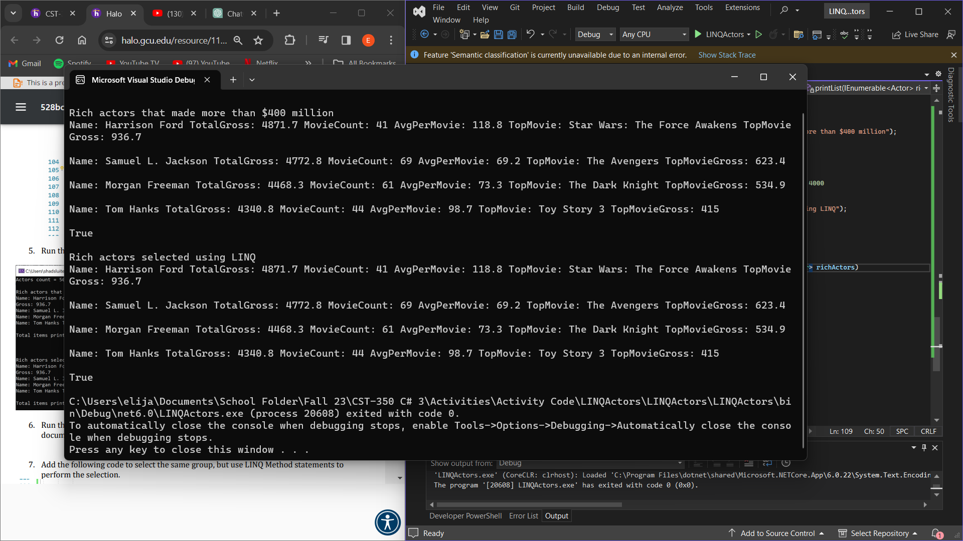

**Screenshot 4-6: Actors with even number of films using for-each loop, LINQ, and Lambda A screenshot of a computer

Description automatically generated**

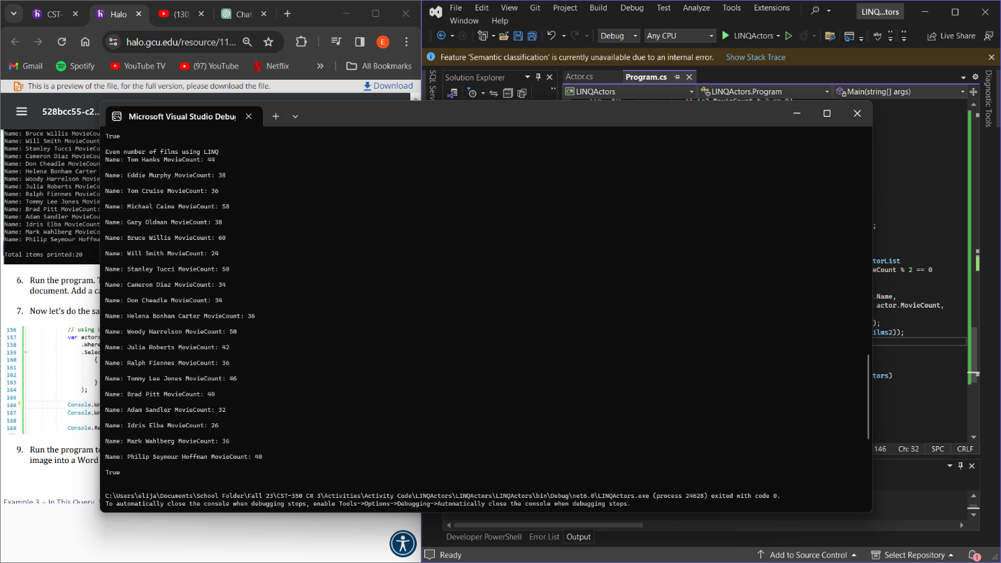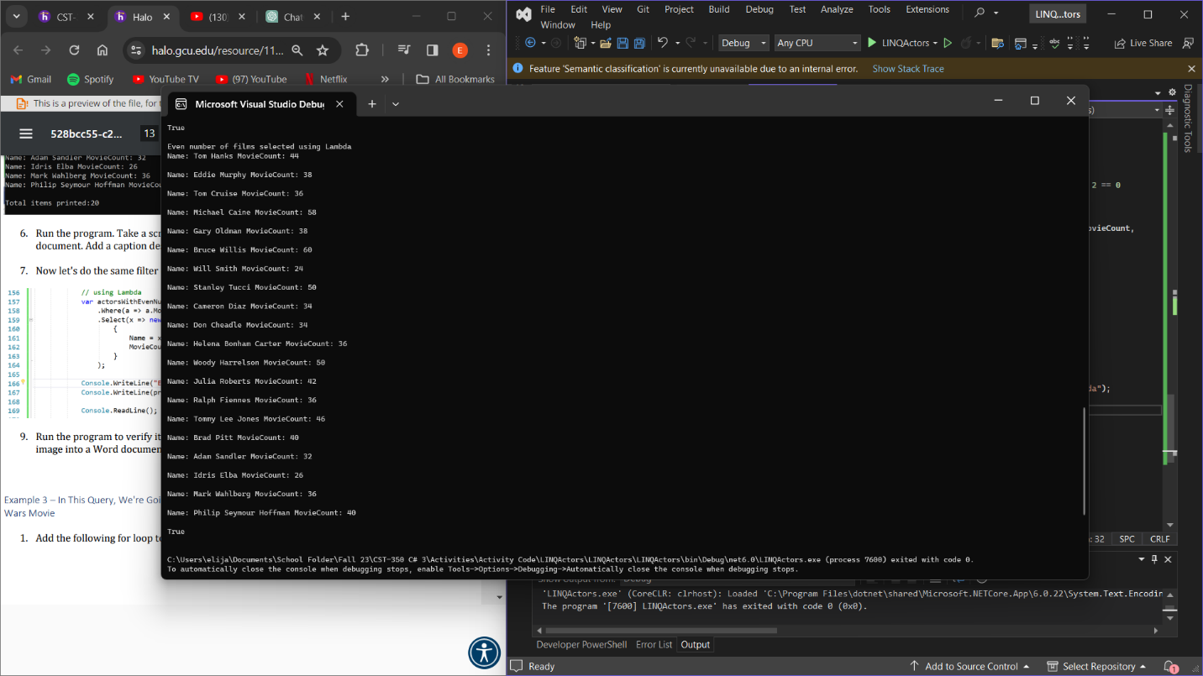

**d**

**Challenge B: I choose to do actors who made over 40 movies, but didn’t make a lot of money per movie**

